HONEY…WE’RE HOME

PROPOSAL

by

Dawn Baker

For

Brent Scott

Capstone Project

Due Date

December 19, 2019

Phase 2 Update

For

Steve George

Due Date

June 4, 2020

Contents

1.0 Description of Web Site: 4

2.0 Goals of the site: 5

3.0 Target Audiences: 5

4.0 Storyboard: 7

5.0 Design Mock-ups 8

5.1 Home Page 8

5.2 About Page 8

5.3 Areas Page 9

5.4 More Page 9

5.5 Contact Page 10

6.0 Qualifications 10

7.0 Timelines/Budget 11

7.1 Phases of Development 11

7.1.1 Planning/Exploration 11

7.1.2 Design/Content 11

7.1.3 Coding/Programming 11

7.1.4 Launch/Maintenance 11

7.2 Line Item Budget 12

8.0 Conclusion 12

8.0 Invoice 13

PROPOSAL PHASE 2 14

2.1.0 Description of Phase 2 14

2.2.0 Collection of Data and How It Will Be Used 14

2.2.1 Neighborhoods Table 14

2.2.2 Users Table 15

2.2.3 Baskets Table 15

2.2.4 Orders Table 15

2.3.0 Interaction 15

2.3.1 Users 15

2.3.2 Administrators 15

2.4.0 Security Considerations 16

XSS Protection 16

Validation 16

2.5.0 Timelines/Budget 17

2.5.1 Design and Content 17

2.5.2 Coding/Programming 17

2.5.3 Launch/Maintenance 17

2.5.4 Phase 2 Pricing 17

2.6.0 ERD and Data Models 18

2.7.0 Front End Dynamic Pages 19

Registration Page 19

19

Success Page 19

19

Login Page 20

20

Login Success 20

20

List View 21

Detail View 22

Add to Basket 22

View Bakset 23

Thank You Page 23

2.8.0 Admin Site Pages 24

Summary List View 24

24

Edit List View 24

Edit Form 25

25

Delete Function 26

26

Delete Success 26

Users List View 26

Baskets List View 27

2.9.0 Sitemaps 28

2.9.1 Front End Sitemap 28

28

2.9.2 Admin Sitemap 28

2.10.0 Phase 2 Invoice 29

2.11.0 Conclusion 30

PROPOSAL

To: scott-media.com c/o The University of Winnipeg

From: Dawn Baker [baker-d39@webmail.uwinnipeg.ca](mailto:baker-d39@webmail.uwinnipeg.ca)

Re: Capstone Project for University of Winnipeg's WDD program

Date: December 19, 2019

# 1.0 Description of Web Site:

“Honey We’re Home” is designed to provide information about the different neighborhoods in the City of Winnipeg. Information available will include safety, traffic, bus routes, convenience to grocery stores and schools. There are always newcomers to the city and the main question they will ask any Winnipeg native is “where is a good place to live?” This is a great opportunity for a Web site that can provide this information.

# 2.0 Goals of the site:

“Honey We’re Home” will provide an interactive Web site targeted primarily to Immigrants looking to move to Winnipeg. The Web site will consist of data collected by crowdsourcing from current and previous residents in those neighborhoods, so the site will include a form section where current residents can vote for their area. It will also include a map of the City of Winnipeg with the neighborhoods listed and a section on news releases and community events. The main goal is that “Honey We’re Home” becomes a crucial stop for any newcomer to the city.

# 3.0 Target Audiences:

Winnipeg has experienced a large influx of immigrants to Winnipeg, many of them refugees and international students, coming here for a better life and education. “Honey We’re Home” will be targeted primarily to immigrants, providing needed information even before they move here, so they will be better prepared knowing what neighborhoods provide the amenities they require. I will have a section that can add ethnic community events, ethnic food stores and where they are located and places of worship.

“Honey We’re Home” would also provide vital information for another demographic; the young single female. Moving out on your own at a young age, and as a female, can be scary enough without having to worry about safe neighborhoods and transportation worries. “Honey We’re Home” can provide that information quickly and easily. There will be a list of Safe Ride options and contact information on the site.

Other audiences, including parents of children moving out on their own, church groups and community centers could find this site informative as well. Social service agencies, providing shelter information for clients, could find this site useful and relay the information to their clients.

As most people are now tech savvy, the site will be mobile friendly with the ability to appear optimized in most browser windows.

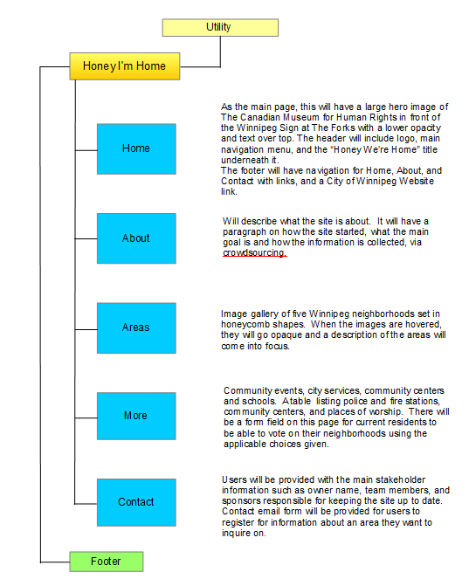4.0 Storyboard:

# 5.0 Design Mock-ups

## 5.1 Home Page

## 5.2 About Page

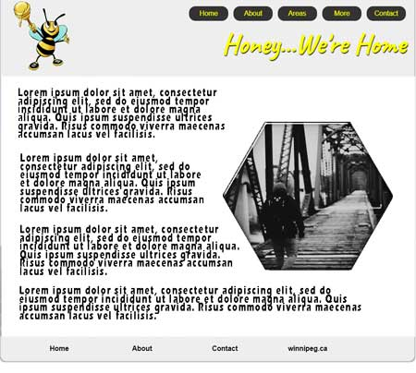

## 5.3 Areas Page

## 5.4 More Page

## 5.5 Contact Page

# 6.0 Qualifications

I am a student in good standing at the University of Winnipeg PACE program, working towards my Web Development Diploma. Courses completed and skills mastered:

* A developing knowledge of Adobe Photoshop and using Type, Layers and Vector Shapes to create Website mock-ups.
* Understand the concepts of contrast, alignment, repetition, and proximity and how they relate to good Web design.
* Know how to create a Web site that is visually appealing and accessible to different audiences.
* Proficient in HTML and understand proper semantic markup and ensuring it will validate properly so there are no issues with display.
* Able to use CSS formatting to make the design of the website user friendly, mobile friendly, and visually appealing.
* Able to create fun animations and use shadows, web friendly fonts, and curved borders to make Web sites interesting.

# 7.0 Timelines/Budget

## 7.1 Phases of Development

### **7.1.1** Planning/Exploration

This phase will be completed on December 11, 2019. On this date I will hand in a draft copy of the proposed outline, sitemap, goals of the site, and target audience descriptions to the instructor for review and approval.

### **7.1.2** Design/Content

This phase of the project will be completed by December 12, 2019. On this date I will have the design mockups completed in Photoshop for approval to begin coding and programming.

### **7.1.3** Coding/Programming

This phase of the project will be completed on December 18, 2019. Beta testing will begin, and any minor issues will be corrected before launch date.

### **7.1.4** Launch/Maintenance

On December 19, 2019, the site will go live on the Salsa server at which time I will present my Capstone Project to my instructor and the class.

## 7.2 Line Item Budget

|  |  |  |  |
| --- | --- | --- | --- |
| **Item number** | **Description** | **Hours** | **Amount (CAD)** |
| 1 | Planning/Exploration | 2 | 30.00 |
| 2 | Design/Content | 5 | 75.00 |
| 3 | Coding/Programming | 50 | 750.00 |
| 4 | Launch/Miscellaneous | 5 | 75.00 |
|  | **Total Cost Budget** |  | **930.00** |

# 8.0 Conclusion

Thank you very much for the opportunity to work on this project and create an interesting website for people looking to move to Winnipeg and know more information about the neighborhoods. I look forward to feedback from you and the public about how this site is functioning in its ability to relay data.

# 8.0 Invoice



# PROPOSAL PHASE 2

To: [edu@pagerange.com](mailto:edu@pagerange.com) c/o The University of Winnipeg

From: Dawn Baker [baker-d39@webmail.uwinnipeg.ca](mailto:baker-d39@webmail.uwinnipeg.ca)

Re: Phase 2 of Capstone Project for University of Winnipeg's WDD program

Date: May 28, 2020

# 2.1.0 Description of Phase 2

Phase 2 of Honey..We’re Home will be to upgrade to PHP and database driven design. This includes creating a database in MySQL and editing the site to use PHP to output dynamic content on some pages instead of static content. This will allow the site to be edited easily as it will rely on database information to populate the fields instead of having to edit each page individually with HTML, which will ultimately save time and make the website easier to manage by anyone administering the site.

There will be a creation of a separate Administrative part of the site, that can only be accessed by authorized users. This will have a login authorization and will include pages where information on each table can be edited. The database will include tables on neighborhoods, users, baskets, and orders and these are tables that will be editable by authorized users using the CRUD principle; Create, Read, Update, Delete.

# 2.2.0 Collection of Data and How It Will Be Used

2.2.1 Neighborhoods Table

Includes information such as name, location in the city, a description, an image, rating scale, services available and house prices. Services data will include whether the neighborhoods have a police station, fire station, library, or pool, based on a yes or no, the number of primary schools, secondary schools, churches, and playgrounds and the names of community centres in the area.

2.2.2 Users Table

A registration form will collect a user’s full name, email, phone number, address, city, province, postal code, country and a password. This registration info will be stored in the database.

## 2.2.3 Baskets Table

Users will be able to create and name a basket that will include the user’s choice of neighborhood and the date the basket was created. Users will be able to have multiple baskets with one neighborhood per basket.

## 2.2.4 O**rders Table**

This table will show list of baskets the user has. Users will be able to delete their baskets at any time they want and create new baskets.

# 2.3.0 Interaction

## 2.3.1 Users

Registered Users will be able to login to the site and view detailed information about neighborhoods from the site and create baskets of neighborhoods that they can view on their profile page. They will be able to add a basket, delete a basket and logout. Unregistered users will not be able to add baskets, just browse the site. If they click on the add to basket a link will direct them to register as a user.

## 2.3.2 Administrators

Administrators will be able to login as admin to access the CRUD site. This will be a mini website that will show a Dashboard page, Neighborhoods page, Users page, Baskets page, and Orders page. Each page will have a list view of all editable entities where the administrator will be able to click on the edit link which will take them to a detail page that will allow them to update and add information. When the submit button is clicked, the database table will update with the new information and show a success or fail message.

# 2.4.0 Security Considerations

## XSS Protection

Cross Site Scripting is an injection type attack on a website designed to inject malicious code into a trusted website and unknowingly access user data and corrupt websites. We will prevent this by sanitizing data and escaping user input before it can be maliciously interpreted.

**CSRF Protection**

Ensure GET requests are free from side effects and that non-GET requests can only be originated from your client-side code. All sensitive data will be accessed through POST requests.

## Validation

A standard Validator form will be used to ensure user and administrator authentication information is correct before submission. All passwords will be encrypted with a hash so only the authenticated user will have access to their password.

Only Administrative users will have access to the backend page, which will prevent unauthorized access to those pages.

# 2.5.0 Timelines/Budget

## 2.5.1 Design and Content

Mock-ups will be completed on April 20, 2020 for approval for Programming

## 2.5.2 Coding/Programming

Creating database tables with fields to accept data, that is inserted into web forms. Coding and programming of existing HTML content converted to PHP, maintaining original design and functionality. Complete validation script and create required pages to output dynamic content to webpages. Create User Registration and login pages. Create Admin site pages, edit pages and process scripts. Will be completed on May 11, 2020.

## 2.5.3 Launch/Maintenance

June 4, 2020 launch date. Final site will go live on Digital Ocean server.

## 2.5.4 Phase 2 Pricing

|  |  |  |  |
| --- | --- | --- | --- |
| **Item number** | **Description** | **Hours** | **Amount (CAD)** |
| 1 | Design/Content | 2 | 30.00 |
| 2 | Coding/Programming | 80 | 1200.00 |
| 4 | Launch/Miscellaneous | 5 | 75.00 |
|  | **Total Cost Budget** |  | **1305.00** |

## 

# 2.6.0 ERD and Data Models

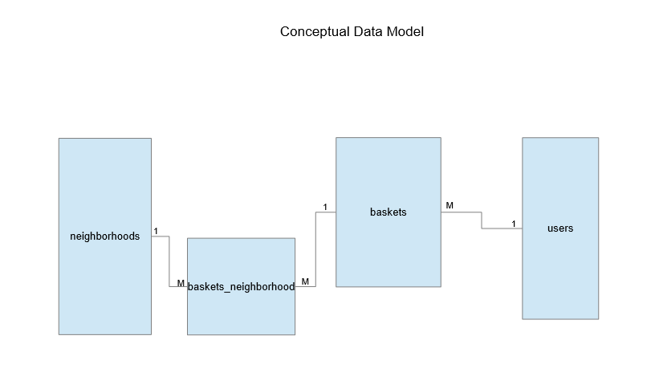

# 2.7.0 Front End Dynamic Pages

## Registration Page

## 

## Success Page

## 

## Login Page

## 

## Login Success

## 

## List View

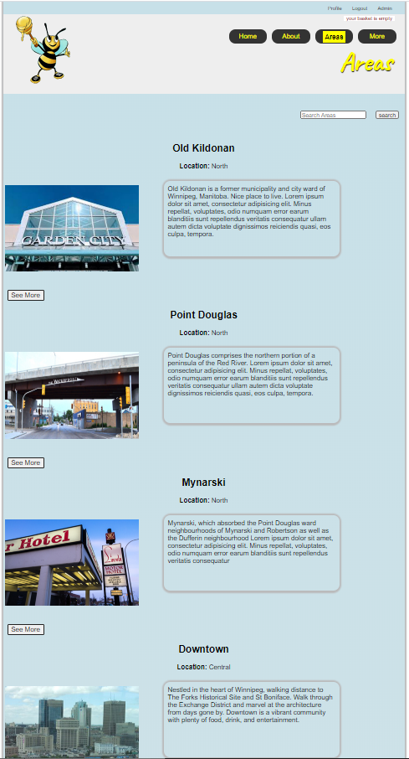

## Detail View

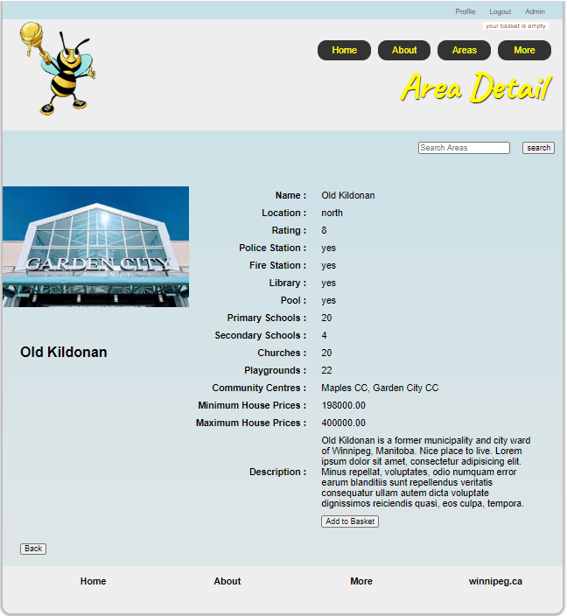

## Add to Basket

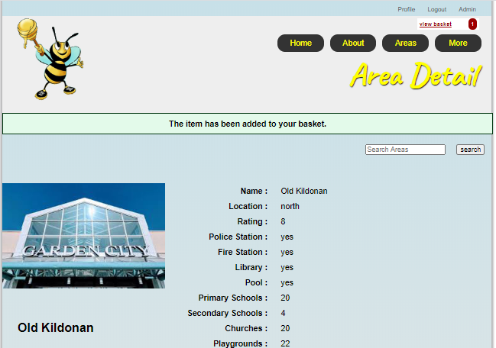

## View Bakset

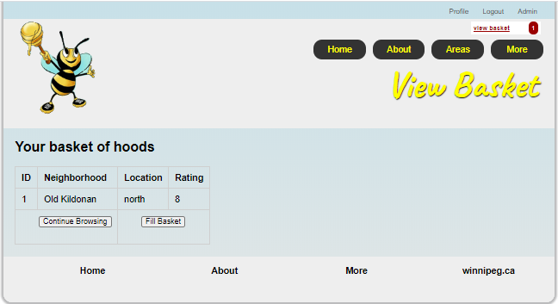

## Thank You Page

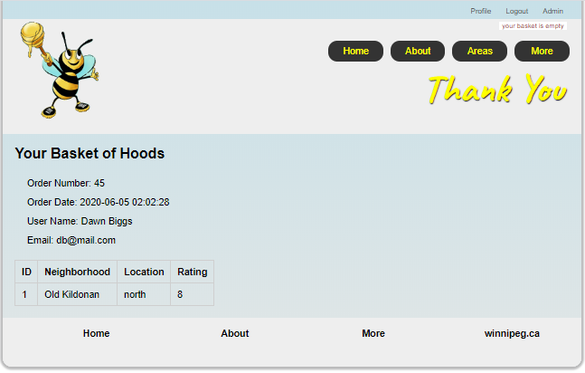

# 2.8.0 Admin Site Pages

## Summary List View

## 

## Edit List View

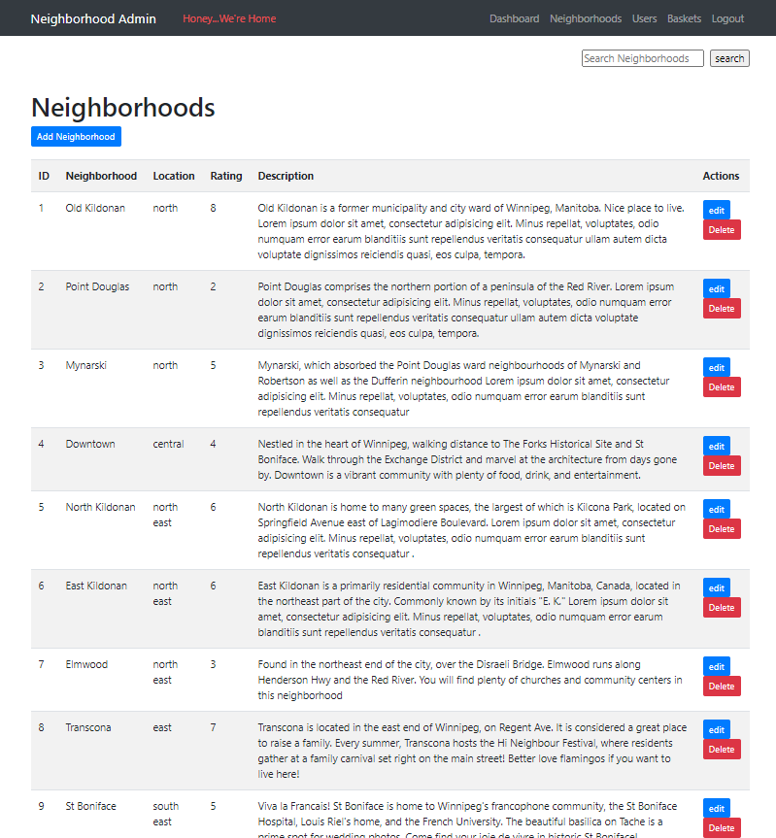

## Edit Form

## 

## Delete Function

## 

## Delete Success

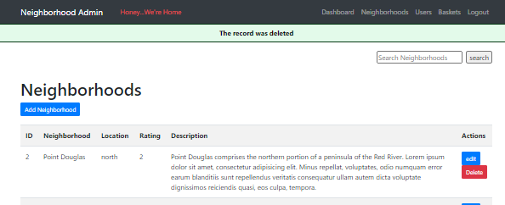

## Users List View

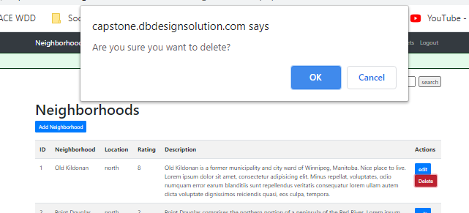

## Baskets List View

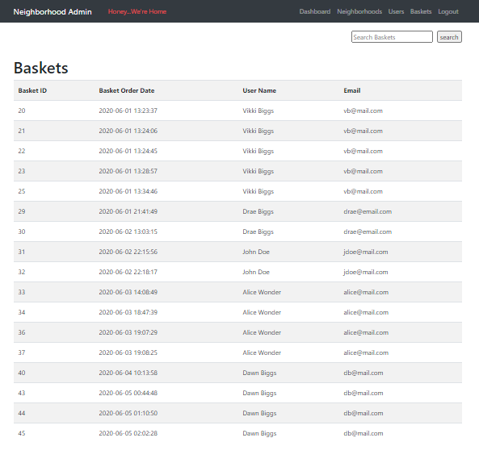

# 2.9.0 Sitemaps

## 2.9.1 Front End Sitemap

## 

## 2.9.2 Admin Sitemap

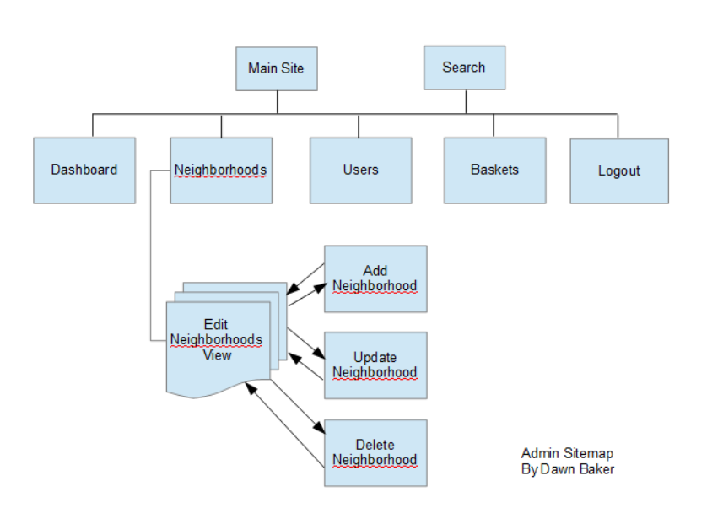

# 2.10.0 Phase 2 Invoice



# 2.11.0 Conclusion

Thank you very much for the opportunity to work on this project and create an interesting website for people looking to move to Winnipeg and know more information about the neighborhoods. We will make your website more user friendly for both the public and for the backend administrative functions. I look forward to hearing your feedback about how we can make this website fully functional, secure and easy to use.